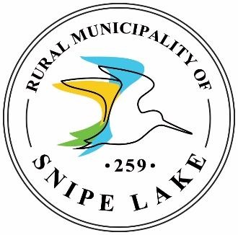
2021 Eston Minor Soccer Registration
Cost: $35/registration Deadline to Register: September 6, 2021
Eston Minor Soccer will take place in the months of September and October and is open to children ages 4-12.
A $10 late fee per registration will apply if submitted after September 6, 2021.
KidSport funding is available for those who qualify and must be submitted with registration by the deadline to qualify.
Registration is not complete until this form, payment and medical information have been received.

Participant Information:

First Name: ______________________ Last Name: ______________________
Gender: Male Female Date of Birth: ____________________
(Please circle) (day/month/year)
2021 Divisions (circle one):
- Ages 4 & 5 (born January 1, 2016 – December 31, 2017)
- Ages 6 – 9 (born January 1, 2012 – December 31, 2015)
- Ages 10 – 12 (born January 1, 2011 – December 31, 2008)
Parent/Guardian Information:
First Name: ________________________ Last Name: _______________________
Relationship to Child: ________________
Mailing Address: ____________________
Town: _____________________________ Postal Code: ______________________
Telephone: _________________________ Email: ___________________________

First Name: ________________________ Last Name: _______________________
Relationship to Child: ________________
Mailing Address: ____________________
Town: _____________________________ Postal Code: ______________________
Telephone: _________________________ Email: ___________________________

I am interested in coaching: Yes No

Medical Information:

After returning the registration form, you will receive an email containing a link to the e-Pact online medical form. If you have completed the medical information previously, you will still be asked to ensure that all information is up to date. Athletes will not be allowed on the field until the medical information is completed.

Required Equipment:
- Running shoes or cleats
- Shin guards are optional
Consent:
I understand and agree that this information is being collected for the purpose of Eston Minor Soccer registration and may be used to update the athlete of upcoming sports he/she may be interested in.
It is a condition of participation that the athlete does so at his/her own risk. The Eston & District Recreation Board is not liable in any way for loss, damage or injury resulting from participation in this program.
I understand that it is the responsibility of the parent/guardian to keep the Recreation Director informed of any change in the above information as well as medical information as soon as possible. In the event of an injury, if no one can be contacted, staff may take my child to a hospital or doctor if deemed necessary. I authorize doctors and nursing staff to examine, investigate and treat my child as necessary.
I authorize release of information to the appropriate parties and photos of my child to be taken and used for promotional purposes.

Signature: ________________________ Date: _______________________
OFFICE USE ONLY
Total: ____________________________ Date Payment Received: _____________
Staff Initials: ______________________ Receipt #: __________________________

